1. Algorithm Visualizer

Algorithm Visualizer is a web-based software developed by Jason Park with his team. This software can be easily accessed through any modern web browser with the URL. Besides, it is an open source project, and its source code is available on GitHub. It mainly allows users to open specific code of an algorithm and play an animation of it.

The first image of this software is modern design in dark mode. However, this kind of appearance is normally programmer oriented and may not be friendly to newcomers. The main page is basically formed by four parts, algorithm menu, animation stage, console and a code text editor. The structure of this software is clear, but no tutorial is provided the first time enter this page. No tutorial may lead to confuse of newcomers.

As for the algorithm menu, common algorithms are classified by their principles and almost all the common sorting algorithms are supported in this software. A search bar also enables users to search a specific algorithm they want to visualise. The animation stage will display the sorting process with bars with different colours and the animation play speed can be controlled through buttons and a progress bar. The console will print all the information during the running process as a record tool. The code part is well designed with syntax highlight and statement which is under processing will be highlighted for the convenience of tracking. Moreover, this software provides several programming languages for the code part. User can switch programming language by simply click a button at the top left corner. A point which is always ignored is the ability of receiving feedback. This software provides the contact information of the team and is open for feedback. However, this software does not support languages other than English, which may hinder users who are not an English speaker.

In the repository of this project, each algorithm is well explained, while no relevant information is shown on the web page. This could be a drawback for someone who want to know more detail about a specific algorithm.

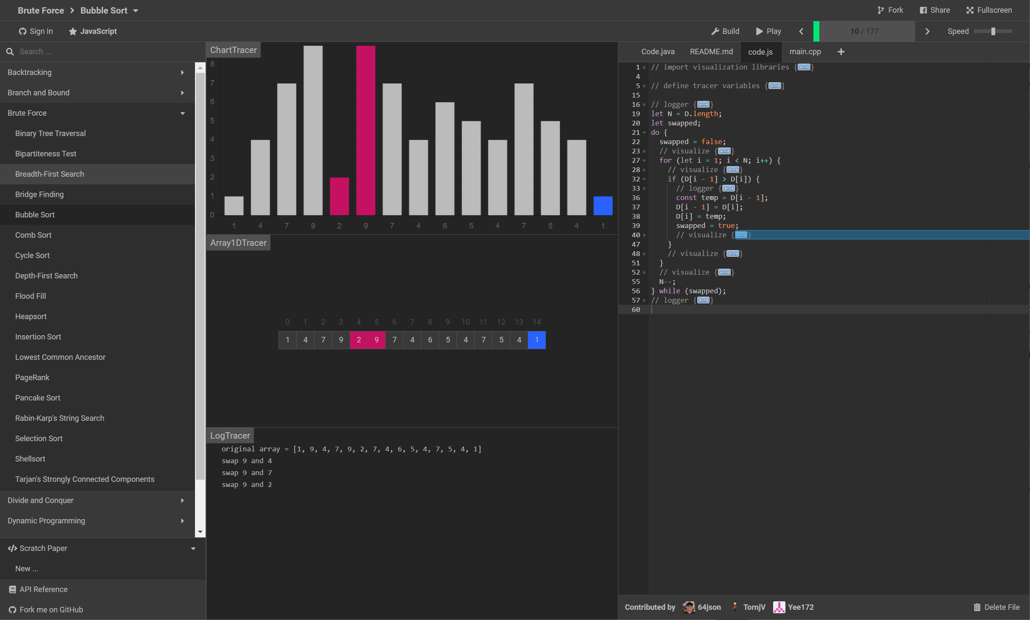

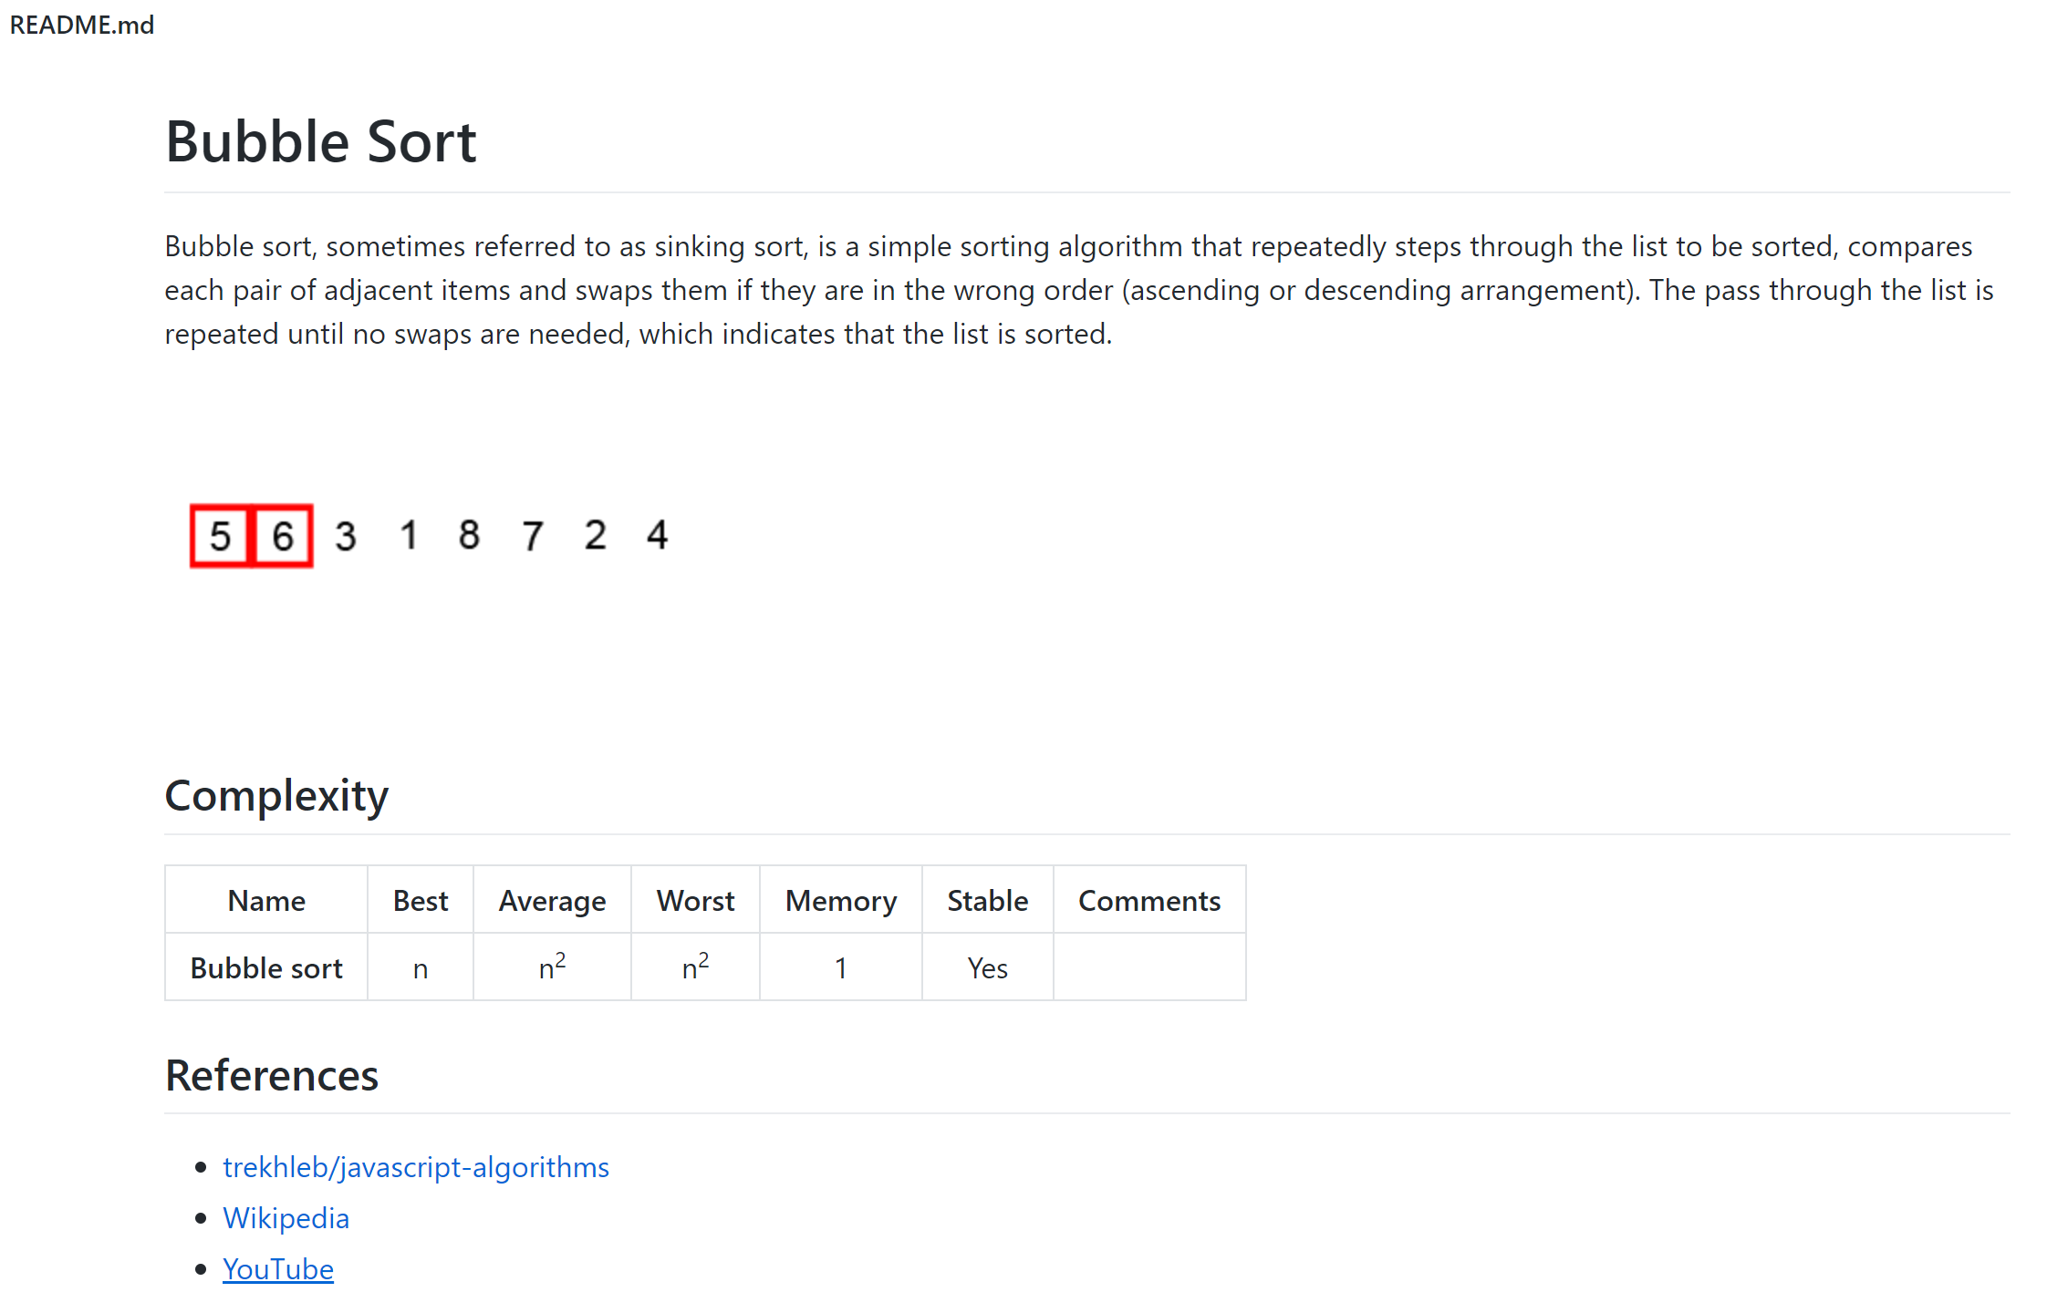

References:

https://algorithm-visualizer.org/

https://github.com/algorithm-visualizer/

2. WeChat MiniProgram

This software can be accessed by scanning a QR code using WeChat. Since it is based on WeChat, it supports mobile devices well and no installation is required. As a light-weighted software, it only supports six basic sorting algorithms with default input array of numbers.

This software consists of a code part on the left and an animation part on the right. As for the left code part, it only supports code in JavaScript. For the animation part, a simple description of the current sorting algorithm is shown beneath the bars. Buttons are located at the top of the software. Choosing algorithms feature is hidden under the hamburger button in blue. The green play button will trigger the animation and the red one will reset the process.

Although this software contains limited features, they are all basic and practical. This also makes this software concise and easy to use. However, only providing real programming language is not friendly for newcomers. No English support would be another problem for users.

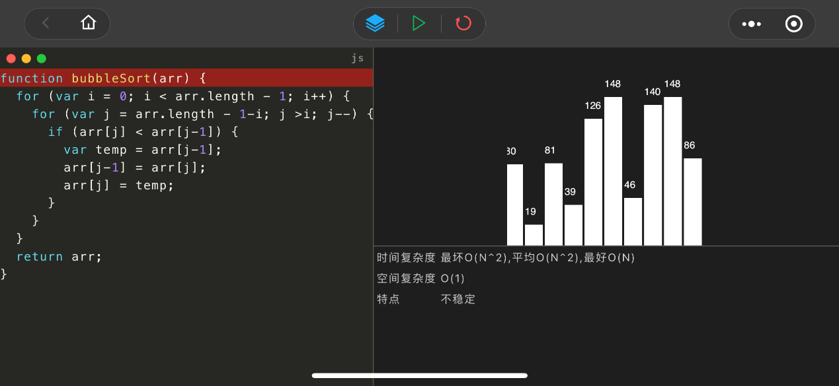



3. Algorithms Explained and Animated

This software is based on the platform of iOS, so only iPhone and iPad can donwload and use this app. On the other hand, this provides the mobility of the learning process. In other word, user can learn or check algorithms anywhere and anytime without a computer.

The structure of this app can be acceptable for newcomers. There are two parts specifically for two purposes. The one with the sorting algorithm name on it is for study prupose, i.e. the software introduce how a specific sorting algorithm works by both animation of bars sorting process and description below. User cannot shuffle bars of numbers since it is a predefined animation. The other one is called simulate, which allows user to shuffle bars of number with three strategies and watch the animation either step by step or automatically. Moreover, a balance is under two bars being compared, which is streight forward for user to understand comparing stategies of different sorting algorithms.

There are also both limitations and advantages in terms of mobility. Due to the limited display size of mobile devices, this app does not support any code of programming language. User cannot set an array of integers on their own. However, language support is good for this app. The language this app uses alters following the iOS system language, but users cannot switch language directly in the app.

